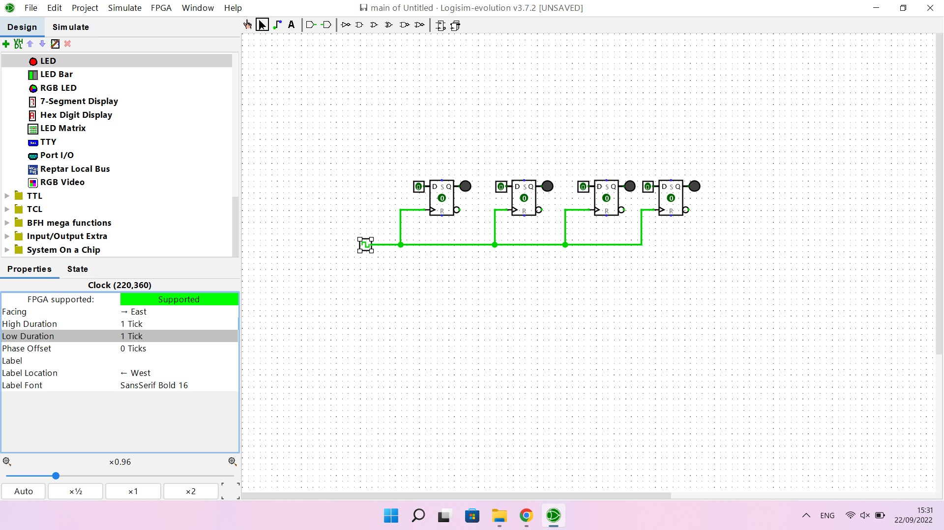

| Ox | Input binary | Output binary |
| --- | --- | --- |
| 0 | 0000 | 0000 |
| 1 | 0001 | 0001 |
| 2 | 0010 | 0010 |
| 3 | 0011 | 0011 |
| 5 | 0101 | 0101 |
| A | 1010 | 1010 |
| B | 1011 | 1011 |
| C | 1100 | 1100 |
| D | 1101 | 1101 |
| E | 1110 | 1110 |
| F | 1111 | 1111 |

7.1

It can let designers modify different time settings for different purpose

7.2

The clock pulse ripples through the circuit.

8

The most significant byte resides in the smallest memory address

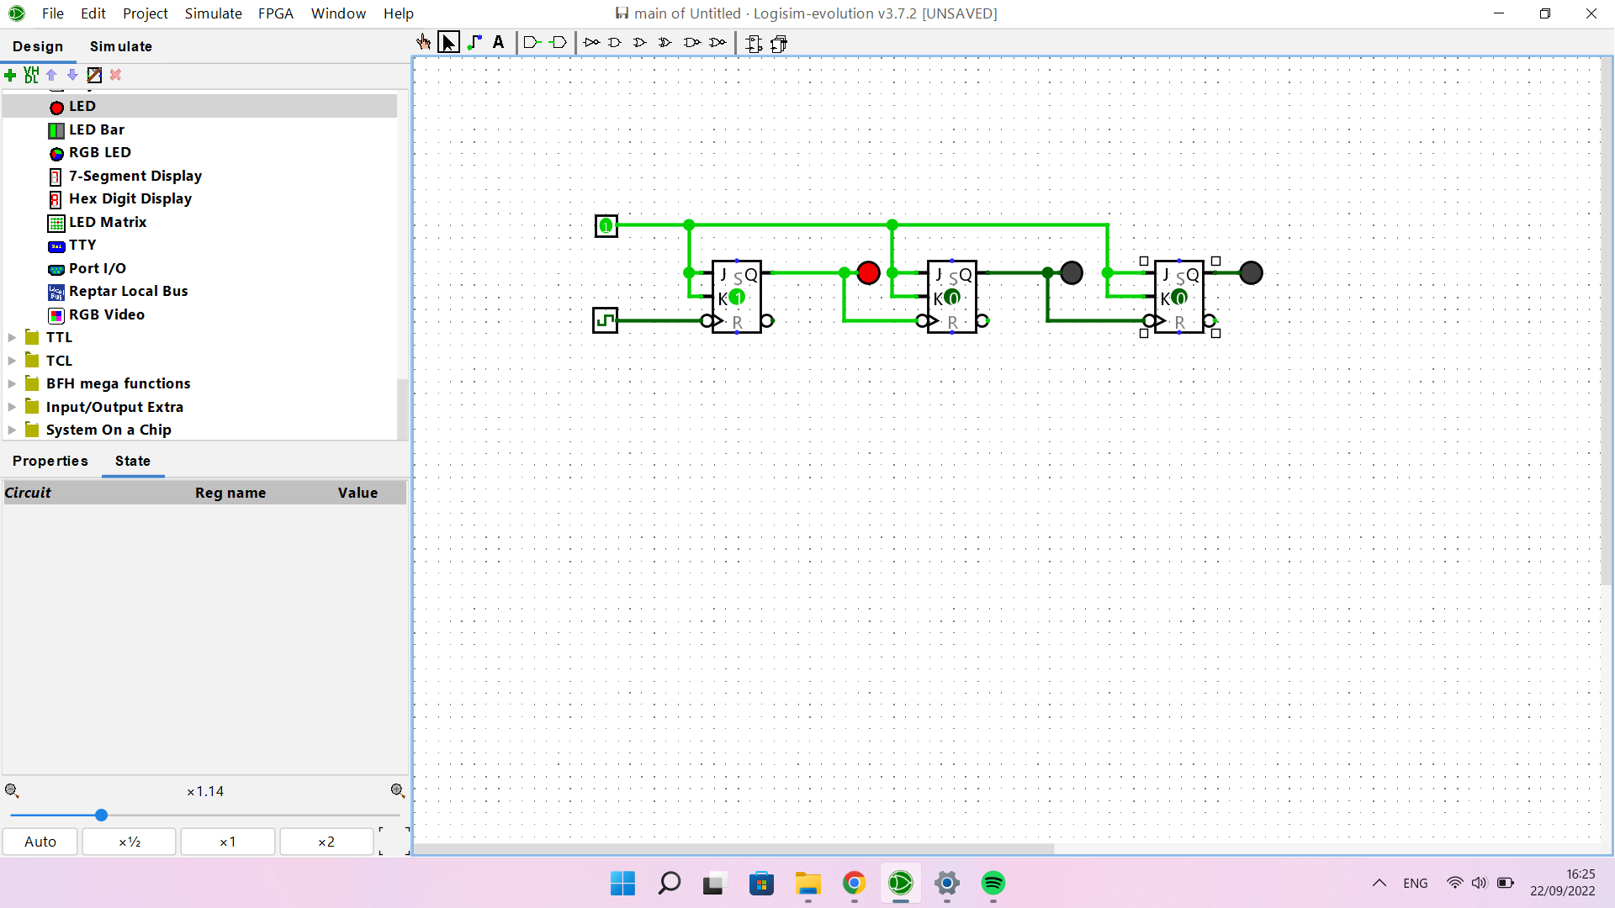

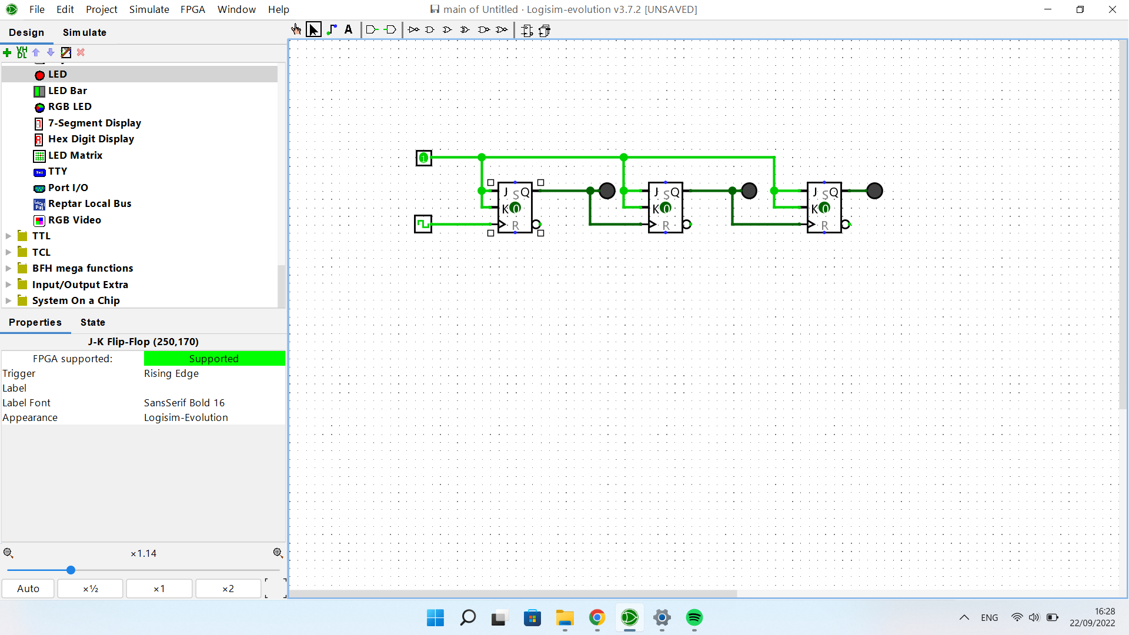

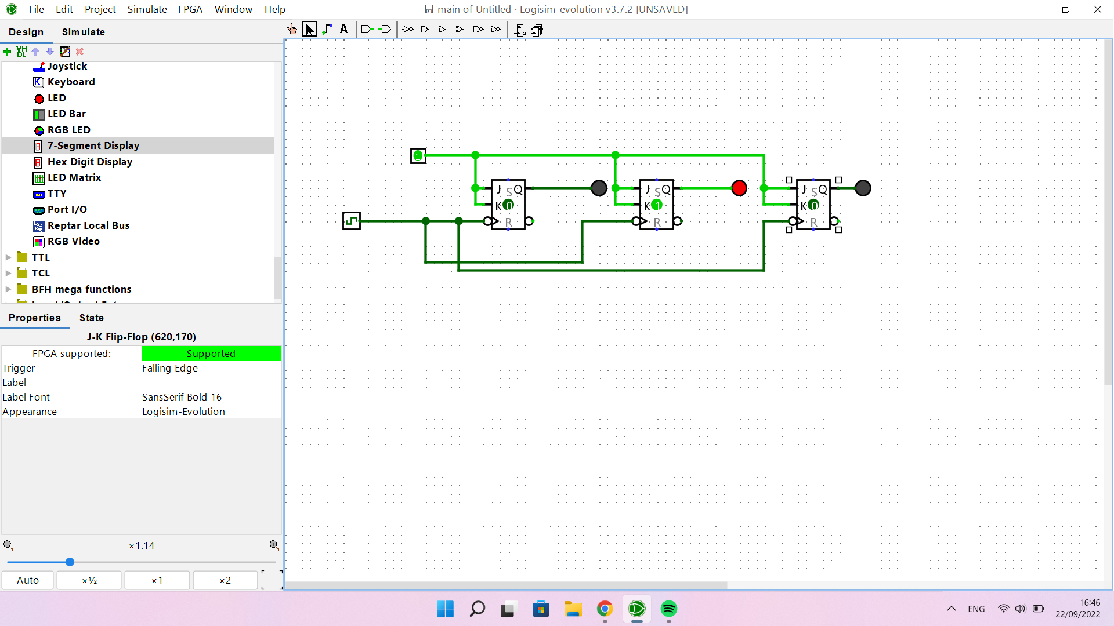

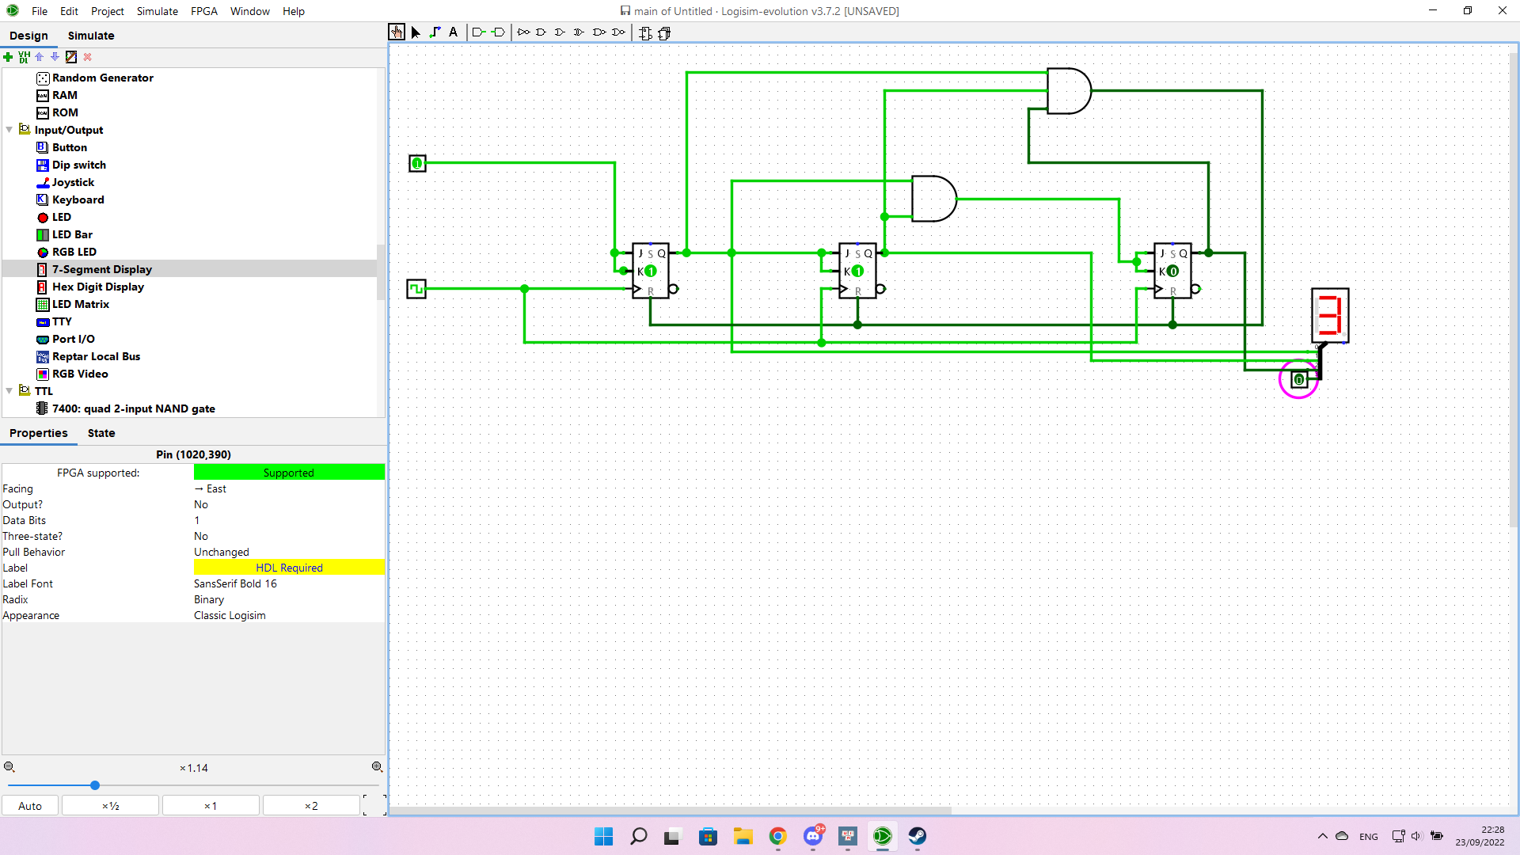

17.2

Otherwise it will result in an incorrect final state